SECTION JA

ENGINE LUBRICATING OIL CIRCUIT

ENGINE LUBRICATING OIL CIRCUIT

(Figs JA.l and JA.2)

Oil is drawn from the sump (47) via suction strainer (52) by two gear type pumps mounted on the underside of the crankcase at the drive-end of the engine and driven from the crankshaft via an idler gear. The idler gear bearings are supplied with oil from a delivery port via drillings (53). From the pumps the combined oil flow is conveyed through connecting pipe (54) and pipe (42) to the free-end cover.

Entering the free-end cover, oil flows via oilways (41) to the thermostat (38) mounted on 'B' bank side of the free-end cover. The thermostat controls the temperature of the oil circulating through the engine. When the oil is cold, the thermostat will remain in the closed position and all oil will flow, via oilway (36), to outlet port (28) formed in the upper, 'B' bank, corner of the cover. As the oil temperature rises, the thermostat will partially open to permit a portion of the oil flow to pass, via oilway (34), through the oil cooler (19). The cooled oil returns to free-end cover and outlet port (28) where it mixes with uncooled oil entering via oilway (36).

Relief valve (23) mounted on top of the cover on 'B' bank side of the engine and connecting with outlet port (28), controls the pressure of oil in the circuit. Relieved oil returns to the sump via oil drain (25), cooling the torsional vibration dampers en-route.

From outlet port (28) oil leaves the engine for the main oil filters where, after filtration, it returns to enter via inlet (30). Oil entering the engine is conveyed, via oilways (29) and (31), to the main oil gallery (37).

Oilways (39) convey oil to the main bearings (43) and the hollow crankshaft journals; the exception is the drive-end bearing (57) which is supplied with oil from the adjacent No 9 main bearing (56) via reservoir (93) in the crankshaft. The hollow journals are used as reservoirs from which oil is supplied to the connecting rod assemblies (see Inset E).

From the large-end bearings, oil is conveyed via drillings (87) along the length of the connecting rods to lubricate the small end bearings (86), and spray drillings (83) where it is sprayed on to the underside of the piston crowns for cooling purposes. The pistons, rings and cylinder walls are splash lubricated from the pressure fed bearings and by oil mist within the crankcase.

Angled oilway (60) in the drive-end wall of the crankcase conveys oil from drive-end crankshaft reservoir (58) to the camshaft drive intermediate gear spindle (See inset C), and then to drilling (63) which conveys oil to the 'A' and 'B' bank fuel injection pump drive idler gear spindles (See inset D). Connecting with drilling (63) are oilways (64) and (61). Oilway (64) provides lubricant to the tachometer generator drive (Section HE), whilst oilway (61) supplies the oil operated two position overload stop (if fitted)(Section HC).

Vertical drilling (22)(See Inset J) conveys oil from the main gallery to camshaft free-end bearing housing (18) and then, via adaptor (17), to free-end cam follower housing (121). The coolant circulating pump bearings are supplied with oil from the adaptor via restrictor plunger (119). Drilling (118) in the pump spindle provides lubricant to the driving splines.

Transfer of oil between the cam follower housings is by 'T' shaped interconnecting pipes

1. , the vertical legs of which supply oil to camshaft bearing housings (5). Drilling (14) (see Inset K) in the coolant pump drive centre bearing housing (124) conveys oil from No. 3 tappet housing to lubricate the bearings, drilling (123) in the spindle providing lubricant to the driving splines at both ends. The drive-end cam follower housing is drilled to supply oil to the coolant pump drive (see Inset B) and drive-end camshaft bearing (66). Drilling (74) in the spindle provides oil to lubricate the drive splines.

LIMITED RIGHTS LEGEND

USE, DUPLICATION OR DISCLOSURE OF THIS INFORMATION WHICH IS THE PROPERTY OF GEC DIESELS LIMITED BY THE U.S. GOVERNMENT OR BOLLINGER IS SUBJECT TO THE RESTRICTIONS SET FORTH IN DOD FAR SUPP 252.227-7013 (a) 15.

Drilling (62) through the drive-end camshaft journal supplies oil to camshaft thrust collar (65) and to the governor drive spur and gear bearings (69) (See Inset A) via a hollow thrust collar bolt, and then via drilling (70) through the governor drive housing to vertical spindle (71). Drilling (72) supplies oil to the vertical spindle bearings.

Lateral oilways (114)(see Inset H) in cam follower housings (113) convey oil from oilway (112) to the follower bores and then via a metering slot in the bodies, and drillings in the bodies and roller pins (117), to the roller bearing bushes. Further drillings in the cam follower bodies supply oil to push rod cups (115) and then via hollow push rods (68) to rocker levers (9). Oilways (10) in the rocker levers supply oil to the tappet pads, bridge pieces, guide columns, valves and springs, and via radial drillings in the rocker lever fulcrum shafts to the rocker lever bushes. Oilways (13) drain excess oil from the valve spring pockets to gallery (15) at the front of the heads, the heads being interconnected by ferrules. The galleries drain from both ends, the free-end oil being piped to ports (35) at each side of the free-end cover, whilst the drive-end oil spills into the gear compartment via cast oilways in the cylinder head bridge block supports (12).

Oil for lubrication of the fuel injection pump camshaft bearings is supplied from free-end cover oilway (31) via drillings (24) and is piped to cambox free-end covers (44). Oil is passed from the covers to hollow camshafts (48) via a plain transfer shaft on 'A' bank side of the engine, and via a combined transfer shaft/bevel gear (107)(see Inset G) on 'B' bank side. Each camshaft bearing surface is supplied with oil via a radial drilling (46) through its journal.

The fuel feed pump drive spindle is also supplied with lubricating oil from 'B' bank cambox free-end cover via drilling (108)(see Inset G). Drilling (109) through the drive spindle supplies oil for lubrication of thrust bearing (110), whilst excess oil is drained back to the cambox via drain oilway (106). Oil in the cambox returns to the crankcase via drain pipe (49) which connects with crankcase door (50).

Oil for lubrication of the fuel-injection pumps is taken from free-end cover oilway (31) and is piped to transfer drillings (45) opposite each injection pump position in both camboxes. Oil enters the cambox through each transfer drilling to fill the annulus formed between the cambox housing and the fuel injection pump body. From the annulus oil is supplied to each pump tappet through oilway (100)(See Inset F) in pump body (96) and then via a metering slot in the tappet body and drillings (98) and (97), to the tappet roller bearing.

The oil supply to each pump plunger is taken from the cambox via non-return valve (101), pump body drilling (102) and barrel drilling (103) to annulus (95) in the barrel bore. This forms a collar of high pressure oil around plunger (94) which prevents passage of fuel down the plunger and into the lubricating oil circuit and also lubricates the plunger and barrel. Non-return valve (101) prevents the possibility of a flow back of fuel into the lubricating oil circuit.

The turbocharger is supplied with oil from free-end cover oilway (31) via pipe (20). To reduce oil pressure for the turbocharger lubrication system a restrictor assembly is incorporated midway along this supply pipe. Refer to Section M for turbocharger internal lubrication. Drain oil from the turbocharger returns to the engine cambox via oil drain piping (2).

Branch pipe (3), off turbocharger supply pipe, supplies oil for lubrication and operation of the overspeed trip mechanism. For details of oil flow, refer to Section HC.

The engine governor is a self-contained unit. For lubrication details, see Section HA.

A lubricating oil sampling valve is fitted to the free-end cover on 'B' bank side of the engine. The valve is padlocked in the closed position. Oil samples should be taken with the oil at normal operating temperature and with the engine running at 'idling' speed.

LIMITED RIGHTS LEGEND

USE, DUPLICATION OR DISCLOSURE OF THIS INFORMATION WHICH IS THE PROPERTY OF GEC DIESELS LIMITED BY THE U.S. GOVERNMENT OR BOLLINGER IS SUBJECT TO THE RESTRICTIONS SET FORTH IN DOD FAR SUPP 252.227-7013 (a) 15.

Key to Numbers

1. Governor drive
2. Coolant circulating pump drive
3. Camshaft drive idler gear
4. Fuel-injection pump drive idler gear
5. Pistons, connecting rods, large and small end bearings
6. Fuel-injection pump
7. Oil transfer to fuel-injection pump camshaft and fuel feed pump drive
8. Cam follower and cylinder head supply

J. Cambox free-end bearing and coolant circulating pump supply

K. Coolant circulating pump drive centre bearing housing supply

1. Turbocharger Oil Inlet Connection
2. Drain oilway from turbocharger
3. Supply pipe to overspeed trip mechanism
4. Turbocharger
5. Camshaft bearing housing
6. Cylinder head
7. Oil drain ferrule
8. Interconnecting pipes, cam follower and camshaft bearing housings
9. Rocker lever
10. Rocker lever drilling
11. Rocker lever fulcrum shaft
12. Cylinder head bridge block support
13. Drain drillings from valve spring pockets
14. Oil way, cam follower housing to coolant pump drive centre bearing
15. Cylinder head drain oil gallery
16. Engine camshaft
17. Adaptor, crankcase to coolant pump and free-end cam follower housing
18. Camshaft free-end bearing
19. Lubricating oil cooler
20. Oil supply to turbocharger
21. Oil supply pipe to ‘B’ bank fuel- injection pumps
22. Oilway to camshaft free-end bearing
23. Relief valve
24. Oil supply to ‘B’ bank fuel injection pump cambox
25. Oil drain from relief valve
26. Lubricating oil filter (5 micron) (if fitted)
27. Oil supply pipe, free-end cover to filter
28. Oil outlet port to main filters
29. Return oilway from main filters
30. Oil inlet port from main filters
31. Oil gallery in free-end cover
32. Inlet oil gallery in free-end cover
33. Oil supply pipe to ‘A’ bank fuel- injection pumps
34. Oilway, thermostat to outlet oilway
35. Port for drain oil from cylinder heads
36. Oilway to oil cooler
37. Main oil gallery
38. Lubricating oil thermostat
39. Oilway to main bearing
40. Supply to ‘A’ bank f.l.p. camboxes
41. Oilway to thermostat
42. Delivery pipe lubricating oil pump to free-end cover
43. Main bearing
44. Free-end cover, fuel pump cambox
45. Transfer drilling
46. Radial drilling to camshaft bearing
47. Lubricating oil sump
48. Fuel-injection pump camshaft
49. Drain pipe from fuel pump cambox
50. Crankcase drain door
51. Fuel injection pump cambox
52. Suction strainer
53. Oil supply drilling to lubricating oil pump idler gear
54. Connecting pipe lubricating oil pump delivery
55. Lubricating oil pumps
56. No. 9 main bearing
57. Drive-end (No. 10) Main bearing
58. Drive-end crankshaft reservoir
59. Oilway, main gallery to No. 9 main bearing
60. Angled oilway
61. Supply drilling to oil-operated overload stop (if fitted)
62. oilway to governor drive
63. Cross drilling to fuel pump idler gear
64. Supply drilling to tachometer generator drive (if fitted)
65. Camshaft thrust collar
66. Camshaft drive-end bearing
67. Drive-end cam follower and coolant pump drive housing
68. Push rod

Colour Code

Main Pressure oil circuit

RED

YELLOW

GREEN

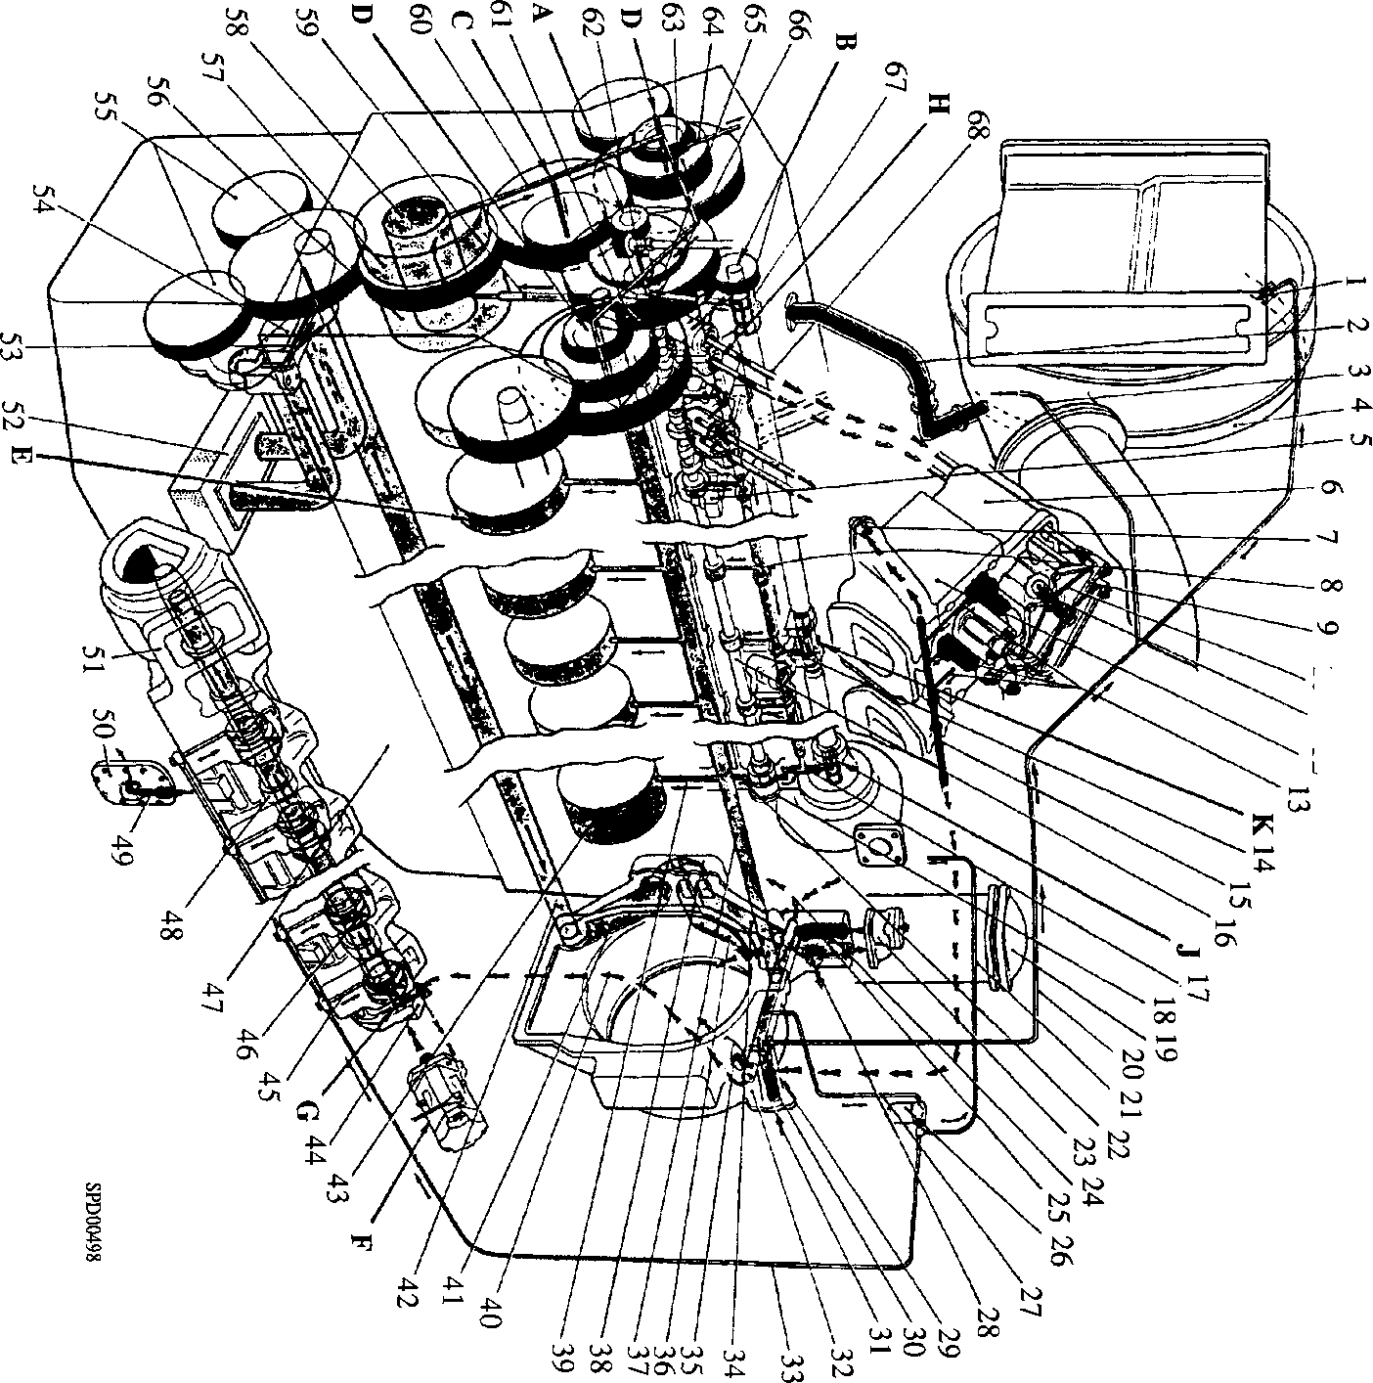Oil for injection pump lubrication and sealing, filtered to 5 micron Pressure free and oil drain

10 11 12

Fig JA.l Diagrammatic arrangement of lubricating oil system

**Colour Code**

Main Pressure oil circuit

RED

YELLOW

GREEN

Oil for injection pump lubrication and sealing, filtered to 5 micron Pressure free and oil drain

Key to numbers (Contd)

1. Worm and spur gear bearing
2. Drilling to vertical drive spindle
3. Vertical drive spindle
4. Oilway to vertical spindle bearings
5. Coolant pump drive gear
6. oilway for cardan shaft spline lubrication
7. Crankcase
8. Camshaft idler gear spindle
9. Camshaft double idler gear
10. Fuel pump drive Idler gear spindle
11. Bevel gears for overspeed trip and tachometer generator drives
12. Small gear, fuel pump idler
13. Large gear, fuel pump idler
14. Crankshaft
15. Oil spray drilling
16. Piston
17. Gudgeon pin
18. Small-end bearing
19. Drilling through connecting rod
20. Forked connecting rod
21. Centre connecting rod
22. Centre connecting rod bearing
23. Forked connecting rod bearing
24. Bearing cap
25. Journal oil reservoir
26. Fuel injection pump plunger
27. Annulus for oil collar
28. Fuel injection pump body
29. Drilling through tappet roller pin
30. Drilling through tappet body
31. Fuel injection pump tappet
32. Oilway in fuel-injection pump body
33. Non-return valve
34. Drilling through pump body
35. Drilling through pump barrel
36. Pump barrel
37. Fuel feed pump
38. Drain drilling
39. Combined oil transfer shaft/bevel gear
40. Oilway to fuel feed pump drive
41. Drilling through fuel feed pump drive spindle
42. Thrust bearing
43. Fuel feed pump drive housing
44. Longitudinal oilway through cam follower housing
45. Cam follower housing
46. Lateral oilway to cam follower
47. Push rod cup
48. Cam follower roller
49. Cam follower roller pin
50. Oilway for cardan shaft spline lubrication
51. Restrictor plunger
52. Coolant circulating pump
53. Free-end cam follower housing
54. Coolant pump drive cardan shafts
55. Oilway for cardan shaft spline lubrication
56. Coolant pump drive centre bearing housing

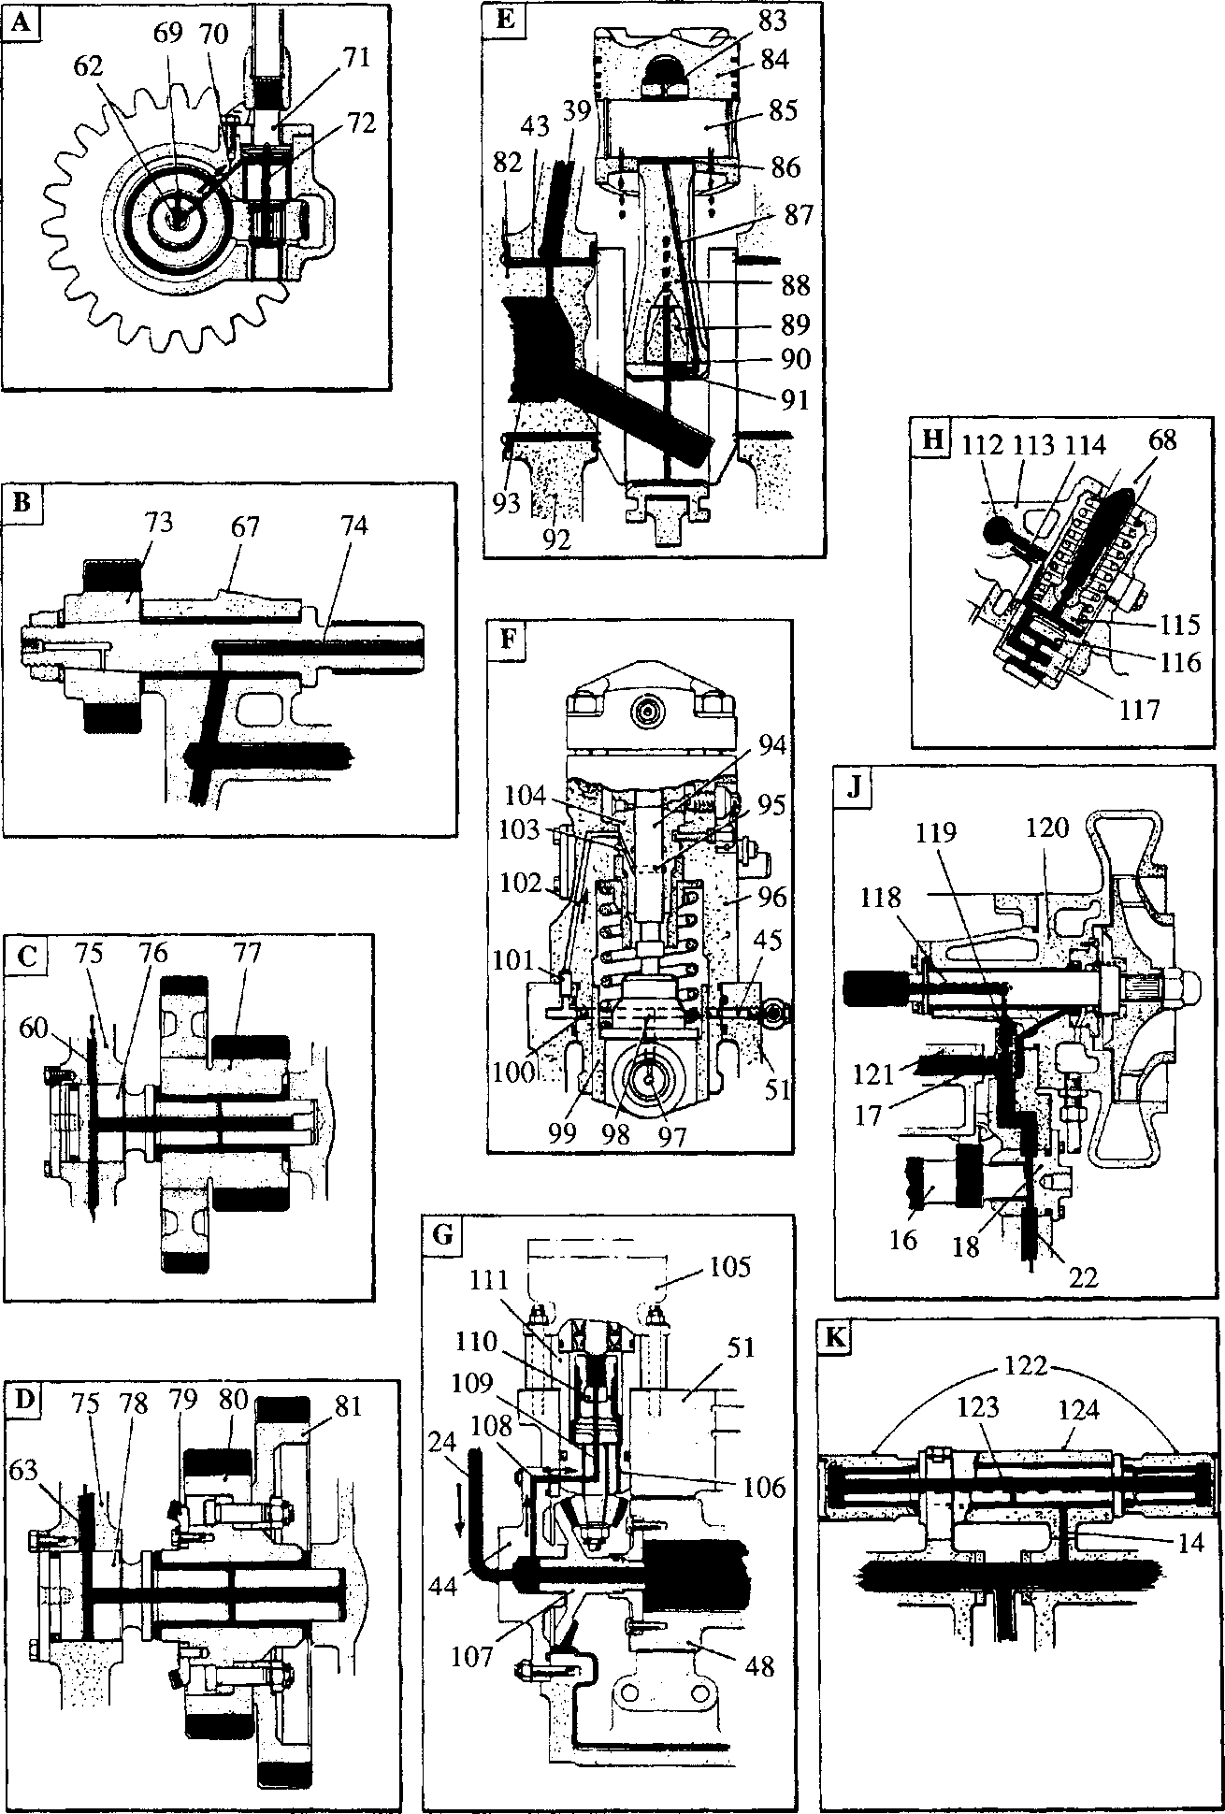

**SPD00499**

**JA.2 Diagrammatic arrangement of lubricating oil system**

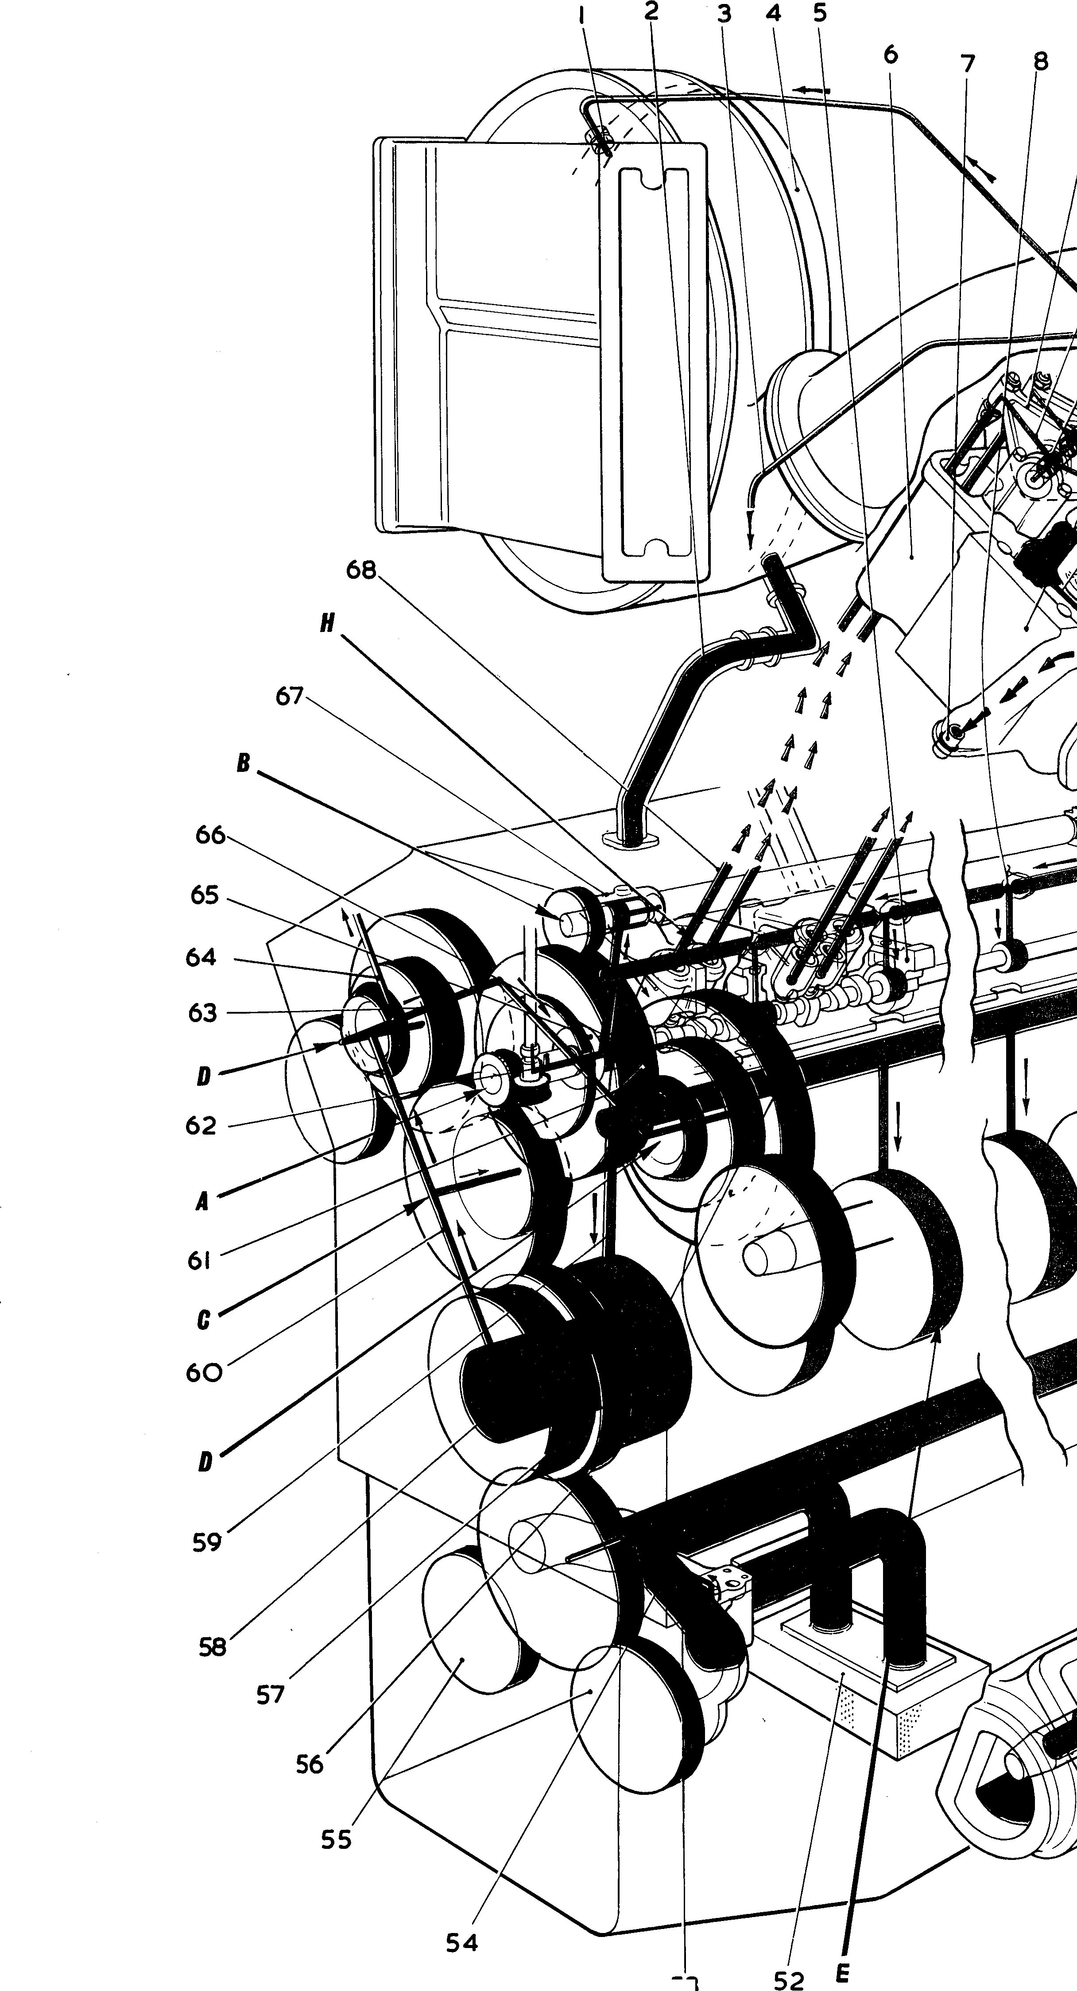

53

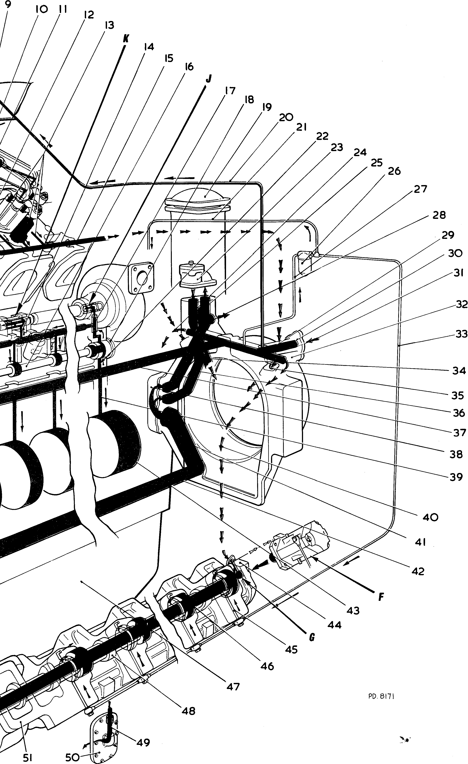

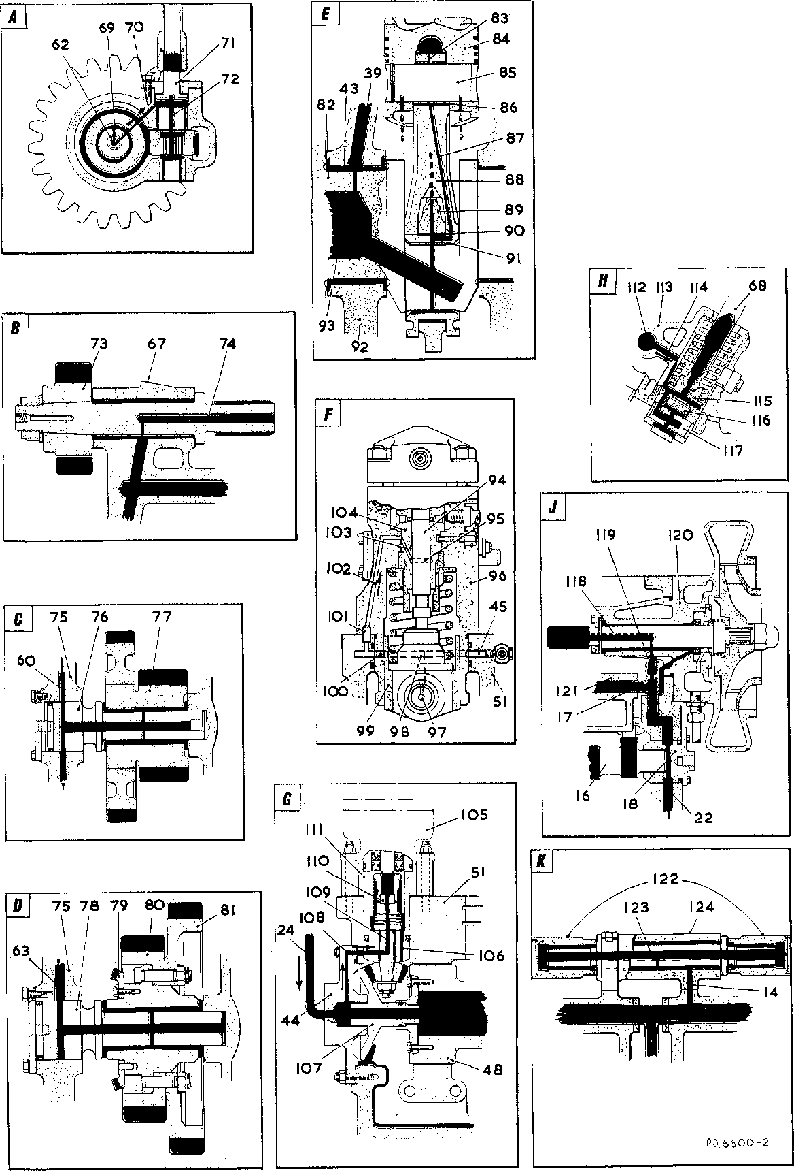

**RED - Main pressure oil circuit**

**YELLOW - Oil for injection pump lubrication and sealing - filtered to 5 micron GREEN - Pressure free and drain oil**

**Key to Numbers**

**PLATE 200J/A6 DIAGRAMMATIC ARRANGEMENT OF LUBRICATION 16 CYLINDER 'VALENTA' (Class RP200) ENGINE**

Colour Code

1. Governor drive
2. Coolant circulating pump drive
3. Camshaft drive idler gear
4. Fuel-injection pump drive idler gear
5. Pistons, connecting rods, large and small end bearings
6. Fuel-injection pump
7. Oil transfer to fuel-injection pump camshaft and fuel

feed pump drive

1. Cam follower and cylinder head supply

J. Cambox free-end bearing and coolant circulating

pump supply

K. Coolant circulating pump drive centre bearing

housing supply

1. Turbo-charger Oil Inlet Connection
2. Drain oilway from turbo-charger
3. Supply pipe to overspeed trip mechanism
4. Turbo-charger
5. Camshaft bearing housing
6. Cylinder head
7. Oil drain ferrule
8. Interconnecting pipes, cam follower housings and

camshaft bearing housings

1. Rocker lever
2. Rocker lever drilling
3. Rocker lever fulcrum shaft
4. Cylinder head bridge block support
5. Drain drillings from valve spring pockets
6. Oilway, cam follower housing to coolant pump drive

centre bearing

1. Cylinder head drain oil gallery
2. Engine camshaft
3. Adaptor, crankcase to coolant pump and free-end

cam follower housing

1. Camshaft free-end bearing
2. Lubripating oil cooler
3. Oil supply to turbo-charger
4. Oil supply pipe to 'B' bank fuel-injection pumps
5. Oilway to camshaft free-end bearing
6. Relief valve
7. Oil supply to 'B' bank fuel injection pump cambox
8. Oil drain from relief valve
9. Lubricating oil filter (5 micron) (if fitted)
10. Oil supply pipe, free-end cover to filter
11. Oil outlet port to main filters
12. Return oilway from main filters
13. Oil inlet port from main filters
14. Oil gallery in free-end cover
15. Inlet oil gallery in free-end cover
16. Oil supply pipe to 'A' bank fuel-injection pumps
17. Oilway, thermostat to outlet oilway
18. Port for drain oil from cylinder heads
19. Oil way to oil cooler
20. Main oil gallery
21. Lubricating oil thermostat
22. Oil way to main bearing
23. Supply to 'A' bank f. i.p. camboxes
24. Oil way to thermostat
25. Delivery pipe L.O.P. to F.E.C.
26. Main bearing
27. Free-end cover, fuel pump cambox
28. Transfer drilling
29. Radial drilling to camshaft bearing
30. L.O. sump
31. Fuel-injection pump camshaft
32. Drain pipe from fuel pump cambox
33. Crankcase drain door
34. Fuel-injection pump cambox
35. Suction strainer
36. Oil supply drilling to lub. oil pump idler gear
37. Connecting pipe L.O. pump delivery
38. Lubricating oil pumps
39. No. 9 main bearing
40. Drive-end (No. 10) Main bearing
41. Drive-end crankshaft reservoir
42. Oilway, main gallery to No. 9 main bearing
43. Angled oilway
44. Supply drilling to oil-operated overload stop

(if fitted)

1. Oil way to governor drive
2. Cross drilling to fuel pump idler gear
3. Supply drilling to tachometer generator drive

(if fitted)

1. Camshaft thrust collar
2. Camshaft drive-end bearing
3. Drive-end cam follower and coolant pump drive

housing

1. Push rod
2. Worm and spur gear bearing
3. Drilling to vertical drive spindle
4. Vertical drive spindle
5. Oilway to vertical spindle bearings
6. Coolant pump drive gear
7. Oilway for cardan shaft spline lubrication
8. Crankcase
9. Camshaft idler gear spindle
10. Camshaft double idler gear
11. Fuel pump drive idler gear spindle
12. Bevel gears for overspeed tripand tachometer

generator drives

1. Small gear, fuel pump idler
2. Large gear, fuel pump idler
3. Crankshaft
4. Oil spray drilling
5. Piston
6. Gudgeon pin
7. Small-end bearing
8. Drilling through connecting rod
9. Forked connecting rod
10. Centre connecting rod
11. Centre connecting rod bearing
12. Forked connecting rod bearing
13. Bearing cap
14. Journal oil reservoir
15. Fuel-injection pump plunger
16. Annulus for oil collar
17. Fuel-injection pump body
18. Drilling through tappet roller pin
19. Drilling through tappet body
20. Fuel-injection pump tappet
21. Oilway in fuel-injection pump body
22. Non-return valve
23. Drilling through pump body
24. Drilling through pump barrel
25. Pump barrel
26. Fuel feed pump
27. Drain drilling
28. Combined oil transfer shaft/bevel gear
29. Oilway to fuel feed pump drive
30. Drilling through fuel feed pump drive spindle
31. Thrust bearing
32. Fuel feed pump drive housing
33. Longitudinal oil way through cam follower

housing

1. Cam follower housing
2. Lateral oilway to cam follower
3. Push rod cup
4. Cam follower roller
5. Cam follower roller pin
6. Oilway for cardan shaft spline lubrication
7. Restrictor plunger
8. Coolant circulating pump
9. Free-end cam follower housing
10. Coolant pump drive cardan shafts
11. Oilway for cardan shaft spline

lubrication

1. Coolant pump drive centre bearing

housing